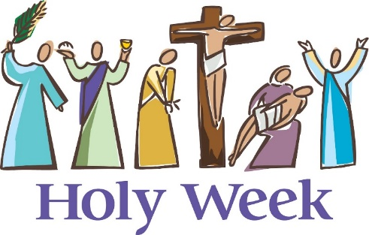

**HOLY NAME PARISH**

**SCHEDULE**

***Holy Tuesday, April 15th***

**No 12:05 p.m. Mass**

***(Chrism Mass at St. Michael’s Cathedral)***

***Holy Wednesday, April 16th***

**12:05 p.m. Mass**

***Holy Thursday, April 17th***

**Mass of the Lord’s Supper at 7:30 p.m.**

*(Led by our African Community Choir)*

**(Bring bells to ring and towels for the washing of feet)**

After Mass, adoration in the Chapel until 11 p.m.

***Good Friday, April 18th***

**Good Friday Service at 3:00 p.m.**

*(Led by our English Community Choir)*

Reminder: Good Friday is a day of Fast and Abstinence for Catholics

***Holy Saturday, April 19th***

**Easter Vigil at – 8:00 p.m.**

Sacraments of Initiation for R.C.I.A Candidates

***(*Bring bells to ring)**

***Easter Sunday, April 20th***

**Easter Mass at 10:00 a.m.**

***(Bring bells to ring)***

**African Catholic Community Mass at 12:00 p.m.**

***(Bring bells to ring)***